Assignment 1
  - Deadline: Day 19/03/2017 @ 23:59
[Total Mark for this Assignment is 8/2=4]

Web Technologies
IT-230

Instructions:
- This Assignment must be submitted on Blackboard via the allocated folder.
- Email submission will not be accepted.
- You are advised to make your work clear and well-presented, marks may be reduced for poor presentation.
- You MUST show all your work.
- Late submission will result in ZERO marks being awarded.
- Identical copy from students or other resources will result in ZERO marks for all involved students.
- Convert this Assignment to PDF just before submission.
Student Details:
Name: ###  CRN: ### |  | ID: ###

Question One
1 Marks

Writ the corresponding HTML code that represent the following output list.

- Section1
  - Subsection1.1
    - Subsection1.1.1
  - Subsection1.2
- Section2
Answer:

Question Two
2 Marks

Discuss the poor user interface issue in term of embedding images in web page, and what is the appropriate HTML element (including its attributes) that used to embed an image in web page?
Answer:

Question Three
2 Marks

Write style sheet and HTML programs for the following design
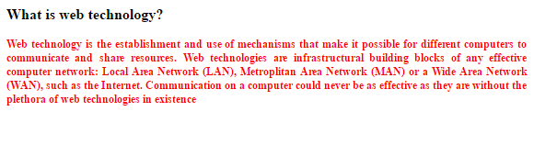

Note: the following conditions should be satisfied
- Content may be anything but it should be like question and answer type.
- Style sheet should be created externally for the following
  - Question font size is 16px, Times New Roman, Justify, bold and font color is black.
  - Answer font size is 12px, Times New Roman, justify and font color is red.
Answer

Question Four
2 Marks

Write style sheet and HTML programs for the following design using universal
selector.



Note: the following points should be incorporated,
- Style sheet should be created externally,
- Use Universal selector for the following,
  - Body background color is blue.
  - All text in italic.
- “Hello this is my page” should be bold, center, font size is 30px, Times New Roman and white color.

Answer

Question Five
1 Marks

What would the browser output ?
<script type = "text/javascript">
<!--
var array = [ [ 1, 2, 3 ], [ 1, 2, 3 ] ];

for ( var i in array )
{
for ( var j in array[ i ] )
document.write( array[ i ][ j ] + " " );

document.writeln("<br />");
}
//-->
</script>

Answer

